1. Download Link: <https://git-scm.com/download/win>
2. Select the 64 bit version of windows.
3. Right click on “Git-2.25.1-64-bit.exe” and click “Run as admin”

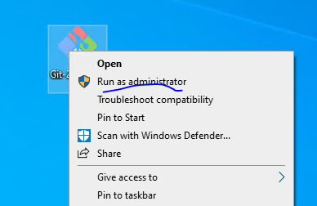

1. Click yes

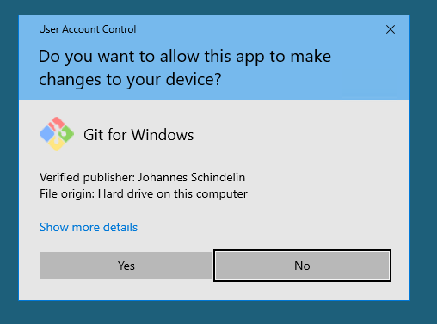

1. Click Next

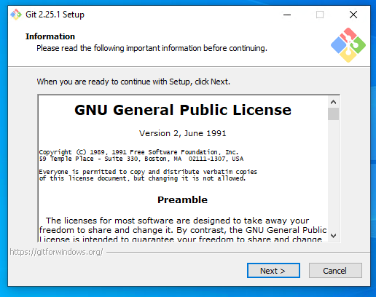

1. Click Next

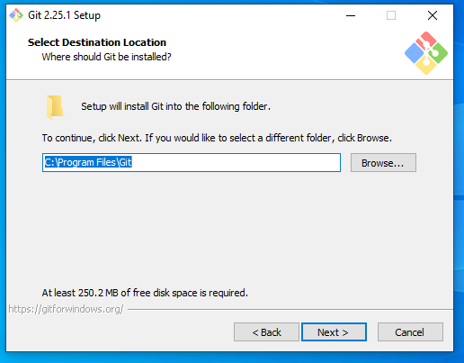

1. Click Next

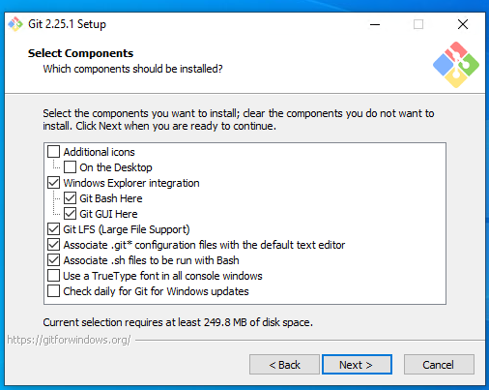

1. Click Next  
   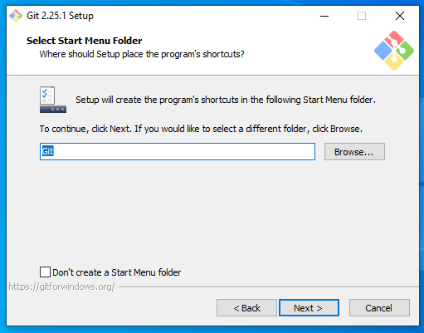
2. Click Next

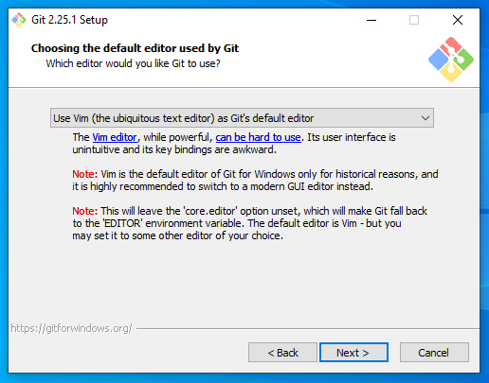

1. Select 3rd option and click Next

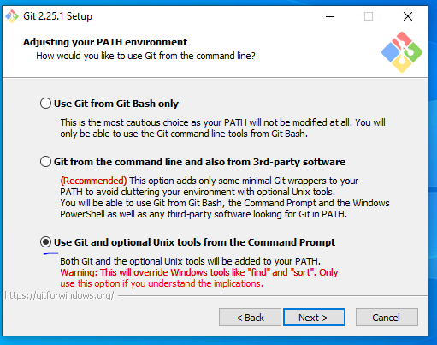

1. Click Next  
   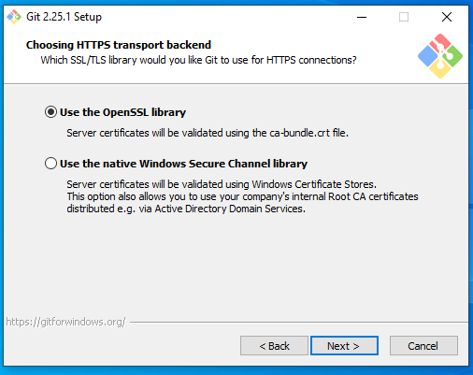
2. Select 3rd option and click Next

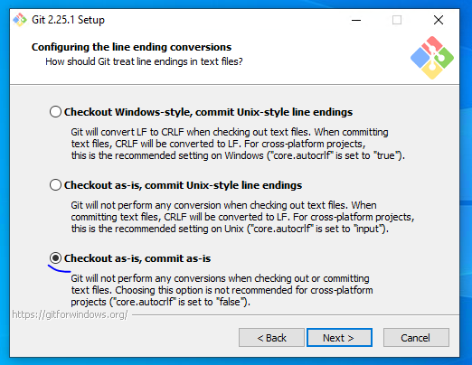

1. Click Next  
   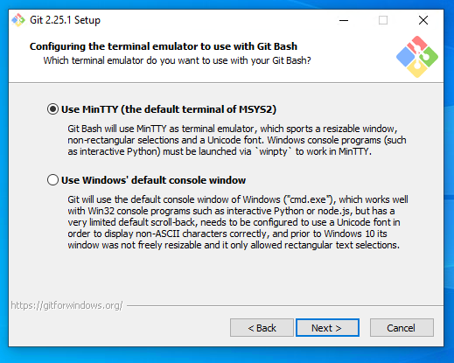
2. Keep only first option and click Install  
   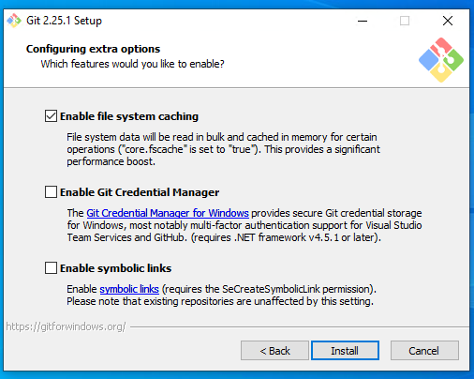
3. Wait for progress to complete

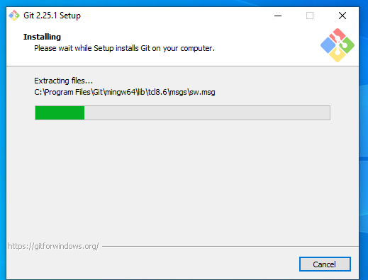

1. Click Next

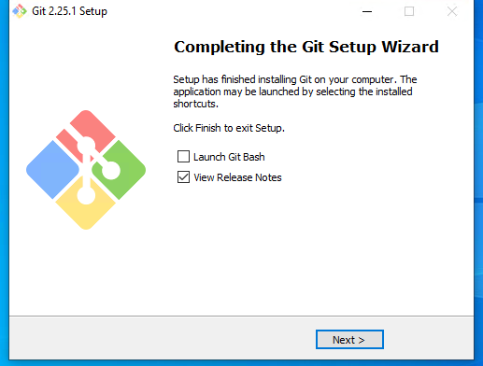

1. Close the Release Notes opened.
2. Right click and see whether context menu added on desktop.

